JULY 2019  Monday | Tuesday | Wednesday | Thursday | Friday | Saturday | Sunday
1  Museum of the American Revolution 10:00am- 5:00pm  Independence seaport museum 10:00am-5:00pm | 2  FIELD TRIP  Wawa hoagie day 12:00pm  and  National Constitution Center  9:30am-8pm  Free Admission: African American Museum  12:00-5:00pm | 3  Free Day at Penn Museum 10:00am-5:00pm  National Liberty Museum 10:00am- 6:00pm  The Galleries at Moore College of Art and Design 11:00am- 5:00pm  PECO Go 4th and learn  10:00am- 12:00pm | 4  Fourth of July!  NSC Closed  Bartram’s Garden House 10:00am-4:00 pm  National Museum of American Jewish History 10:00am- 5:00pm  Independence Day Parade 10am-11am | 5  NSC Closed | 6  Hispanic Fiesta 2:00pm- 8:00pm | 7  Free First Sunday at the Barnes Museum  10am-5pm  Hispanic Fiesta  2:00pm-8:00pm
8  Mindfulness Meditation at Fumo Family Library 1:30pm | 9  FIELD TRIP  Rodin Museum and Garden Tour 11am | 10 | 11  Parks for Chinatown: Game Night  5:00pm-7:00pm | 12 | 13  Caribbean Festival  12pm-8pm | 14
15  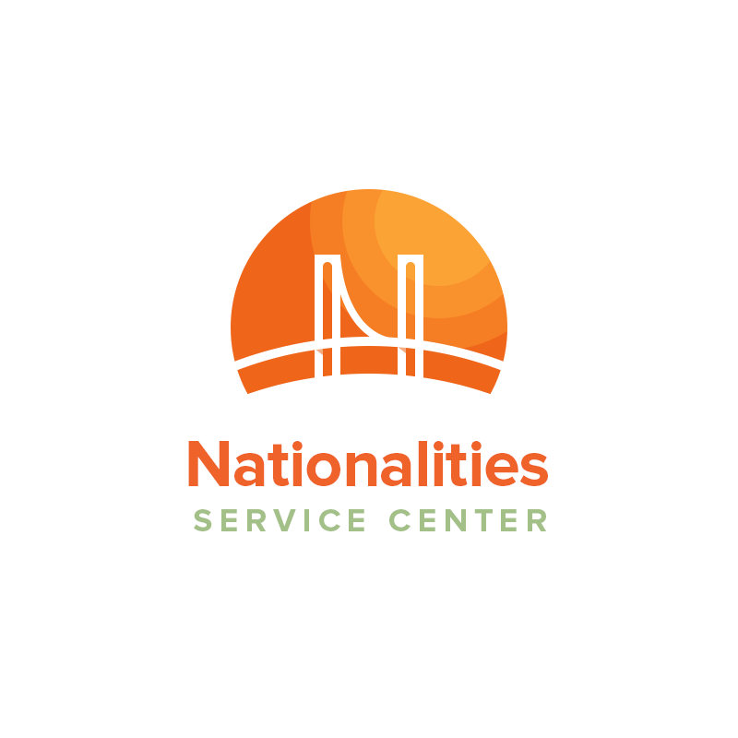 | 16  FIELD TRIP  Art in City Hall Tour 10:00am  A MONTHLY CALENDER of FREE & DISCOUNTED EvENTS IN PHILADELPHIA!  National Career Fair at Four Points by Sheraton Philadelphia  11:00am- 2:00pm | 17  SPECIAL FIELD TRIP: Make Philly Art at City Hall Court Yard  11:00am – 2:00pm | 18  Free Movie Night: Crazy Rich Asians  7:30pm | 19 | 20  EXPLORE PHILADELPHIA!  Islamic Heritage Festival  2:00pm -8:00pm  Philly Vegan Pop Flea 12:00pm- 4:00pm | 21
22 | 23  FIELD TRIP  Philadelphia Free Library Tour 1:00pm | 24  RAIN DATE for Make Art Philly | 25  Free Movie Night: Sing 7:30 PM | 26  Free Movie Night: Coco  7:30 PM | 27  Free Movie Night: Zootopia  7:30 PM | 28
29 | 30  FIELD TRIP  Farmers Market Tour  Sahaja Yoga  6:00pm-7:30pm | 31  Free Movie Night: Spider Man 7:30 PM  Job Fair at the Convention Center  10:00am- 6:00pm |  |  |  | Stay tuned for more upcoming events!
ENJOY THE PHILLY SUN!

Event Descriptions
Cultural Events | Field Trip Tuesdays! | FREE Museum Admission | Other Events
El Concilios Hispanic Fiesta:  July 6th & 7th 2:00pm-8:00pm  Location:  - This event raises awareness of Latino culture and community. Enjoy music, dance, entertainment, food and crafts.  Caribbean Festival:  July 13th 12:00pm- 8:00pm  Location: Wiggins Park Marina, 2 Riverside Drive, Camden NJ 08103  - Come out and experience the crafts, sounds, and flavors of the Caribbean community  Islamic Heritage Festival:  July 20^{h} 2:00pm-8:00pm  Location: 101 Columbus Boulevard,  - Includes a fun Parade and Festival with games, speakers, free giveaways, entertainment, and a global market | Wawa Welcome Week Tour:  Free Wawa Hoagie Day & The National Constitution Center  July 2nd 11:00am meet at NSC  Rodin Museum and Garden Tour  July 9th 10am meet at NSC  Art in City Hall Tour  July16th 9:15am meet at NSC  Monday - Friday 10am - 4pm  - The exhibits at City Hall are open to the general public and are free of charge. Photography is encouraged.  SPECIAL FIELD TRIP  WEDNESDAY  Make Art Philly  July 17th 11am - 2pm  (Rain date July 24th Ages & 12)  Free Library of Philadelphia Tour  July 23rd 9:30am meet at NSC  Farmers Market Tour  July 30th 12:00 meet at NSC | Independence Seaport Museum:  July 1st 10am-5pm  Location: 211 S Christopher Columbus Blvd  Museum of the American Revolution: July 1st 10am-5pm  Location: 101 S 3rd St.  Fireman’s Hall Museum:  July 3rd 10am-4pm  Location: 147 N 2nd St.  Mutter Museum: July 3rd 10am-4pm  Location: 19 S 22nd St.  Penn Museum: July 3rd 10am-5pm  Location: 3260 South St  National Liberty Museum:  July 3rd 10am-6pm  Location:321 Chestnut St.  The Galleries at Moore College of Art & Design: July 3rd 11am- 5pm  Location: 1916 Race St.  Eastern State Penitentiary Historic Site: July 3rd 5pm-7pm  Location: 2027 Fairmount Ave  Philadelphia Museum of Art:  July Job Fairs  National Career Fair  July 16, 2019 at 11:00am-2:00pm  Location: Four Points by Sheraton Philadelphia Northeast, 9461 Roosevelt Boulevard  Philadelphia, PA 19114  - A live recruiting and hiring event for future employees. Attend this networking event with the possibility of walking away with a job.  Kappa Alpha Psi Career Fair  July 31st, 2019 at 10am-6pm  Location: Pennsylvania Convention Center, 1101 Arch St, Philadelphia, PA 19107  - A networking event for graduate students, college students, and professionals. Please bring copies of your resume to hand out to employers at the fair.  July 3rd 5pm- 8:45pm  Location: 2600 Benjamin Franklin Pkwy  Batram’s Garden House:  July 4th 10am-4pm  Location: 5400 Lindbergh Blvd  National Museum of American Jewish History: July 4th 10am-5pm  Location: 101 S Independence Mall E  FREE Food Access!  The Summer Meal Program provides FREE snacks to kids and teens age 18 and under throughout the city.  To find out more information about the free food sites please call the toll-free summer meal hotline: 1-855-252-MEAL  Or  Text “FOOD” or “COMIDA” to 87787  Here is the link to the website where you can access more information and find a map of the free food locations  https://www.phila.gov/2019-06-17-philly-summer-2019-update-heres-what-to-do-with-your-kids-this-summer/  Barnes Museum First Sunday  July 7th 10am – 5pm  Location: 2025 Benjamin Franklin Pkwy | Yoga Meditation:  July 30th 6:00 – 7:30 PM  Location: Drexel University New College Building, 245 N 15th St, Philadelphia, PA  Philly Vegan Pop up Flea Market:  July 20th 12pm to 4pm  Location: Friends Center, 1501 Cherry St., Philadelphia, PA 19102.  Make Art at City Hall Court Yard:  11:00am- 2:00pm  Location: City Hall, 1400 John F Kennedy Blvd.  - For families and Children to make free art at City Hall. You don’t want to miss it!  Mindfulness Meditation:  July 8th 1:30pm  Location: Fumo Family Library  2437 South Broad Street  Other Wawa Welcome Week Events:  Independence Day Parade  July 4th 10am-11am  Location: Independence Hall, 520 Chestnut Street  Celebration of Freedom Ceremony  July 4th 10am  Location: Chestnut street between 5th & 6th streets  PECO Go 4th and learn:  July 4th 10:00am- 12:00pm  - Enjoy educational activities, games, music and more! Community members will read books aloud and give away free books.  Free Movie Nights:  Crazy Rich Asians: July 18th 7:30pm  Location: The Great Plaza at Penns Landing  Sing: July 25th 7:30 PM  Location: Walnut Street Bridge  Coco: July 26th 7:30 PM  Location: Laurel Hill Cemetery  Zootopia: July 27th 7:30 PM  Location: Trolley Car Diner  Spider-Man: July 31st 7:30 PM  Location: Mifflin Square Park

On-Going Events
Spruce Street Harbor
Monday- Thursday 11am-11pm, Friday & Saturday 11am-1am, Sunday 11am-11pm
Location: 301 S Christopher Columbus Blvd, Philadelphia PA 19106

Free Tai Chi Classes: Every Tuesday and Saturdays
7:30am – 8:30am
Location: Franklin Square Park (Rain location: Asian Art Initiative Studio C)

The Food Trusts Market at Cherry Street Pier: Every Saturday starting July 13th
10am-2pm

Location: 121 N Christopher Columbus Blvd

Please Touch Museum: Monday, Tuesday, Thursday, Friday, Saturday 9:00am- 5:00pm
Wednesday 10am-5pm, Sunday 11am-5pm
Location: Memorial Hall 4231 Avenue of Republic, Philadelphia, PA 19131
*Access cardholders have a discounted rate of $2.00

English Conversation Group: Every Monday 5:30pm
Location: Philadelphia City Institute, 1905 Locust Street
Join for a FREE conversation hour speaking in English and meet other international adults. Topics involve small talk, holidays, customs, and common English terms.

Parks for Chinatown Game Night: 5:00-7:00pm Every Thursday
Location: 10th Street Plaza

Pay What you Wish: Art Splash Opening Weekend: July 5th- July 7th 10:00am - 5:00pm
Location: Philadelphia Museum of Art 2600 Benjamin Franklin Parkway
Enjoy kid and family friendly art activities including a tour of two art exhibitions, crafts, and a fun

gallery hunt for kids.

