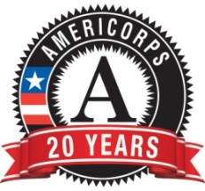
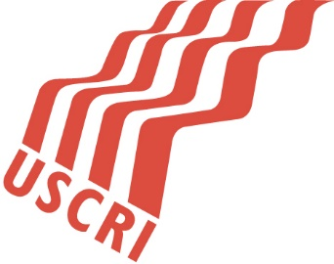
AmeriCorps/Refugee Corps Member
Volunteer Coordinator

Title: AmeriCorps Volunteer Coordinator

Supervisor: Ellen Ramage

Hours: 35-40 hrs. /week
Position Description
Nationalities Service Center prepares and empowers immigrants and refugees in the Philadelphia region to transcend challenging circumstances by providing comprehensive client-centered services to build a solid foundation for a self-sustaining and dignified future. We are the largest non-sectarian organization in the Greater Philadelphia area which provides comprehensive services in the areas of language access and proficiency, legal protections and remedies, community transition and integration, access to health and wellness, and job readiness training to immigrants and refugees. The AmeriCorps/Refugee Corps member will recruit, train, and manage volunteers who will provide refugee clients with English as a Second Language instruction; cultural orientation; mentoring; and assistance with housing, job development, health care, school enrollment, and financial literacy; as well as other services.

Member Roles and Responsibilities
- Recruit and retain community volunteers who will provide direct services and mentorship to newly arrived refugees;
- Create a volunteer orientation and ensure volunteers provide at least one countable hour of services each year;
- Establish tracking systems to monitor volunteer hours and participation;
- Gain knowledge of and incorporate best practices in volunteer management to create a successful volunteer program;
- Design and deliver trainings for volunteers which utilize adult learning methodologies; and
- Effect positive social change through the implementation of new effective systems for volunteer management.

Qualifications
Knowledge or experience with the refugee resettlement program; demonstrated cultural competence and interest in working in a diverse workplace; U.S. citizen or legal permanent resident alien; high school degree or currently enrolled in a GED program; excellent verbal communication skills; driver's license and access to personal vehicle to conduct outreach in community; successful completion of required criminal background check. Former refugee committed to the successful integration of new refugee arrivals highly encouraged to apply.
Skills:
- Speak, read and write fluent English
- Can work independently with volunteers and refugee clients, with minimal supervision
- Good communication skills
- Willing to work in a hectic, sometimes unpredictable environment
- Flexible, in terms of clients being on time for appointments
- Friendly/personable

Term of Service
October 16, 2017- October 15, 2018
Time Requirements
Minimum 35 hours/week; at least 1,700 hours required by the end of the term of service.
Orientation and Training
No more than 180 hours of orientation and training; topics include AmeriCorps/Refugee Corps policies and procedures; volunteer recruitment and management, adult learning principles, instruction/training techniques and evaluation processes, member rights and responsibilities, prohibited activities, requirements under the Drug-Free Workplace Act, suspension and termination from service, grievance procedures, sexual harassment, other non-discrimination issues, and other topics as necessary.
Benefits
Living allowance, post-service education award of $5,815.00, professional work experience, career mentoring; national Refugee Corps network. (Please keep in mind that the Educational award is awarded upon successful completion of the 1700-hour requirement. If the AmeriCorps member leaves for the following reasons, referred to as “exiting for cause”, they are not eligible for the educational award: enrolling in school, obtaining employment, dissatisfied with the program, and for not adhering to the Rules of Conduct in the AmeriCorps Member Service Agreement.
Evaluation and Reporting
Mid and final performance reviews; bi-weekly timesheets; bi-weekly updates to supervisor; Volunteer Database-Tracking volunteer hours; quarterly debriefs with program management to assess progress, Monthly Check in with Program Officers.
To Apply
Please send a resume and cover letter to jobs@nscphila.org. No phone calls please.

